**JOBS (mini book)**

**Cut and make a mini book.**

**bilgeceingilizce.weebly.com**

**She is a teacher.**

**She works at a school.**



**He is a doctor.**

**He works at a hospital.**



**He is a policeman.**

**He works at a police station.**

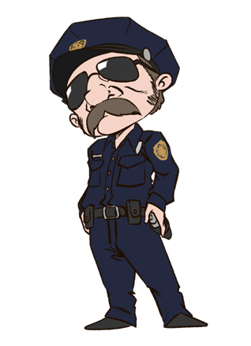

**He is a farmer.**

**He works on a farm.**

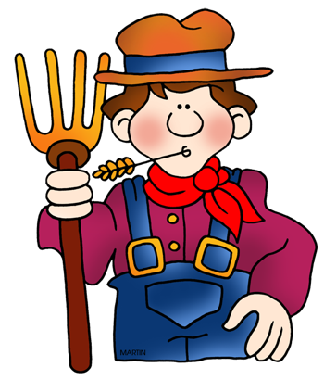

**She is a nurse.**

**She works at a hospital.**



**He is an actor.**

**He works at a theater.**

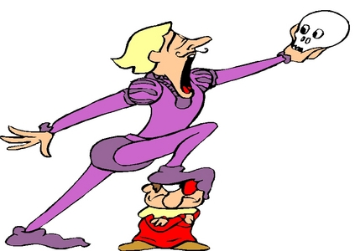

**He is a businessman.**

**He works at a company.**



**He is a fireman.**

**He works at a fire station.**

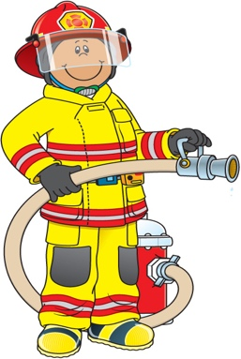

**She is an engineer.**

**She works at a factory.**

